Mark Gameng

**Homework 3 – CS 450 Spring 2022**

**1a. FIFO with 3 pages of physical memory**

|  |  |  |  |  |  |  |  |  |  |  |  |
| --- | --- | --- | --- | --- | --- | --- | --- | --- | --- | --- | --- |
| **P1** | **P2** | **P3** | **P4** | **P1** | **P2** | **P5** | **P1** | **P2** | **P3** | **P4** | **P5** |
| P1 | P1  P2 | P1  P2  P3 | P2  P3  P4 | P3  P4  P1 | P4  P1  P2 | P1  P2  P5 | P1  P2  P5 | P1  P2  P5 | P2  P5  P3 | P5  P3  P4 | P5  P3  P4 |
| **Fault** | **Fault** | **Fault** | **Fault** | **Fault** | **Fault** | **Fault** |  |  | **Fault** | **Fault** |  |

**Total: 9 page faults**

**1b. FIFO with 4 pages of physical memory**

|  |  |  |  |  |  |  |  |  |  |  |  |
| --- | --- | --- | --- | --- | --- | --- | --- | --- | --- | --- | --- |
| **P1** | **P2** | **P3** | **P4** | **P1** | **P2** | **P5** | **P1** | **P2** | **P3** | **P4** | **P5** |
| P1 | P1  P2 | P1  P2  P3 | P1  P2  P3  P4 | P1  P2  P3  P4 | P1  P2  P3  P4 | P2  P3  P4  P5 | P3  P4  P5  P1 | P4  P5  P1  P2 | P5  P1  P2  P3 | P1  P2  P3  P4 | P2  P3  P4  P5 |
| **Fault** | **Fault** | **Fault** | **Fault** |  |  | **Fault** | **Fault** | **Fault** | **Fault** | **Fault** | **Fault** |

**Total: 10 page faults**

With 3 pages of physical memory, the number of page faults was 9, and for 4 pages of physical memory, the number of page faults was 10. This is Belady’s anomaly, having more page faults when increasing the number of pages of physical memory.

**2a. LRU with 3 pages of physical memory**

|  |  |  |  |  |  |  |  |  |  |  |  |
| --- | --- | --- | --- | --- | --- | --- | --- | --- | --- | --- | --- |
| **P1** | **P2** | **P3** | **P4** | **P1** | **P2** | **P5** | **P1** | **P2** | **P3** | **P4** | **P5** |
| P1 (1) | P1 (2)  P2 (1) | P1 (3)  P2 (2)  P3 (1) | P2 (3)  P3 (2)  P4 (1) | P3 (3)  P4 (2)  P1 (1) | P4 (3)  P1 (2)  P2 (1) | P1 (3)  P2 (2)  P5 (1) | P1 (1)  P2 (3)  P5 (2) | P1 (2)  P2 (1)  P5 (3) | P1 (3)  P2 (2)  P3 (1) | P2 (3)  P3 (2)  P4 (1) | P3 (3)  P4 (2)  P5 (1) |
| **Fault** | **Fault** | **Fault** | **Fault** | **Fault** | **Fault** | **Fault** |  |  | **Fault** | **Fault** | **Fault** |

**Total: 10 page faults**

**2b. LRU with 4 pages of physical memory**

|  |  |  |  |  |  |  |  |  |  |  |  |
| --- | --- | --- | --- | --- | --- | --- | --- | --- | --- | --- | --- |
| **P1** | **P2** | **P3** | **P4** | **P1** | **P2** | **P5** | **P1** | **P2** | **P3** | **P4** | **P5** |
| P1 (1) | P1 (2)  P2 (1) | P1 (3)  P2 (2)  P3 (1) | P1 (4)  P2 (3)  P3 (2)  P4 (1) | P1 (1)  P2 (4)  P3 (3)  P4 (2) | P1 (2)  P2 (1)  P3 (4)  P4 (3) | P1 (3)  P2 (2)  P4 (4)  P5 (1) | P1 (1)  P2 (3)  P4 (4)  P5 (2) | P1 (2)  P2 (1)  P4 (4)  P5 (3) | P1 (3)  P2 (2)  P5 (4)  P3 (1) | P1 (4)  P2 (3)  P3 (2)  P4 (1) | P2 (4)  P3 (3)  P4 (2)  P5 (1) |
| **Fault** | **Fault** | **Fault** | **Fault** |  |  | **Fault** |  |  | **Fault** | **Fault** | **Fault** |

**Total: 8 page faults**

This aligns with LRU because with LRU, it is guaranteed to have fewer or the same number of page faults when adding more pages of physical memory.

**3a.**

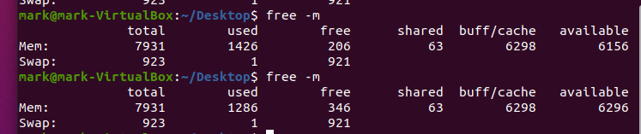

Difference: 140

This amount of difference is expected because we allocated 128mb of memory using malloc. Then we used bzero to fill up the allocated memory which is why there is a difference in free memory before and after pressing enter. Before pressing enter, the allocated memory is filled up, and thus the used memory is 1426mb, but after pressing enter, the used memory becomes 1286. So, the difference is 140 and this is to be expected.

**3b. Commenting out bzero**

Difference: 0

This difference is much smaller than the previous because commenting out bzero is the cause of the difference in free memory. Malloc simply allocates and doesn’t do anything with it. However, with bzero, it places n zero-valued bytes in the area pointed to, in this case p, the allocated memory 128mb. With bzero commented out, it no longer fills up the 128mb allocated memory with 0 bytes, so the memory is still free. Thus, the difference is much smaller, and in this case, there is no difference in free memory. Before pressing enter, the used memory is 1284 and after pressing enter, it is still 1284mb.

**3c. pmap**

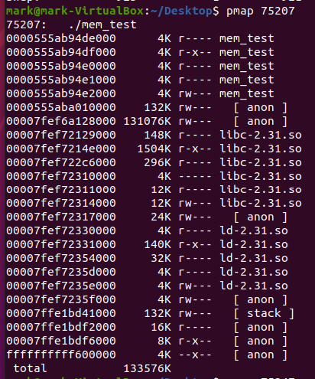

Pmap displays the memory map of the process. The columns are the address of the map, size of map, mode (permissions) and the last column is the files backing the map or [anon] or [stack]. [anon] is for allocated memory (malloc), and [stack] is for the program stack.

The first 4 lines are just the mem_test file with 4kb and all of them are having read permissions but one is also executable denoted by the r-x--. The next two lines are allocated memory, with 132kb and 131076kb. I’m assuming the one with 131076kb, or 131mb, is big due to us allocating 128mb in our program. Not sure what the other allocated memories, [anon], are for though. The size of the map for our program stack is 132kb and has read and write permissions. The other lines are the libraries used, libc-2.31 and ld-2.31. So, the process has its own mapping of the library that it uses and needs.